Potato Market Analysis and Price Trend Prediction
(2019–2025)

Name: Harshitha Paladugu
Course/Project: Market Analysis Internship – Week 1 Task
Week 1 Task: Market Analysis and Trend Prediction

Methodology
- Source: Agmarknet [Agmarknet – https://agmarknet.gov.in]
- Crop: Potato
- Tool: Excel (Pivot Table + Line Chart)
- Process: Collected daily prices → Cleaned data → Grouped by year → Found average yearly prices → Created line chart

Analysis
Year | Avg. Price (₹/quintal)
2019 | ->825
2020 | ->1945
2021 | ->910
2022 | ->1190
2023 | ->1025
2024 | ->1620
2025 | ->1500 (Predicted)

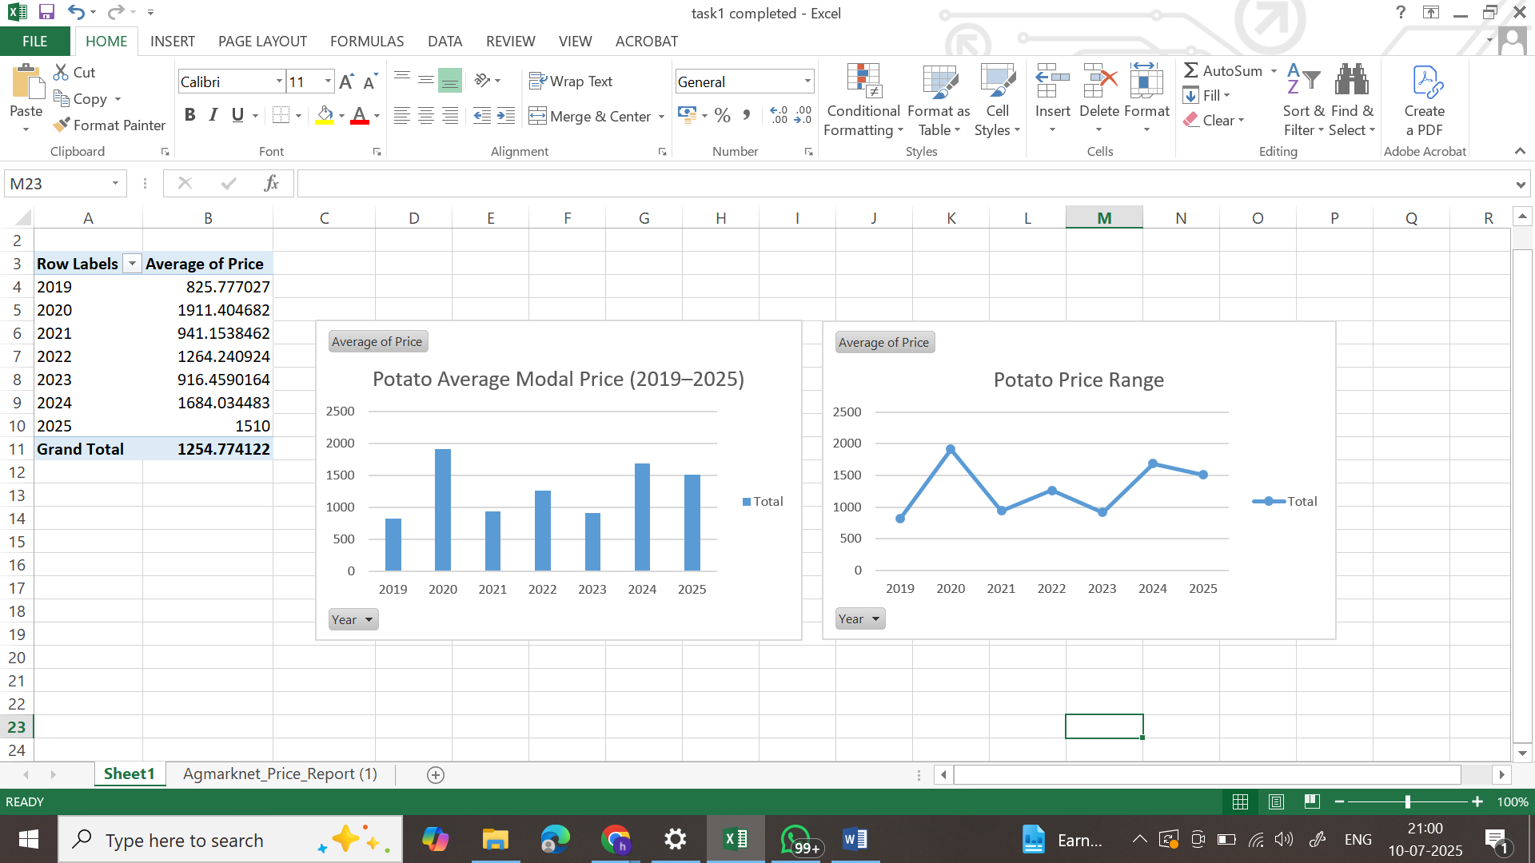
The analysis shows considerable variation in modal potato prices over the years 2019 to 2025.
In 2019, the average price was ₹825, the lowest in the dataset. A sharp increase was observed in 2020, with prices rising to ₹1911, likely due to COVID-related supply disruptions.
2021 and 2023 saw a moderate drop, with average prices below ₹950. A partial recovery occurred in 2022, and a strong upward trend resumed in 2024, reaching ₹1684.
The forecasted price for 2025 is approximately ₹1510, based on this upward trend and calculated through simple linear projection.
The bar chart shows a consistent upward movement from 2023 to 2025, indicating likely market recovery and stable demand.
The line chart highlights sharp spikes and dips, revealing that the potato market is sensitive to external factors like supply chain issues or climate variability.

Conclusion
The analysis shows a clear trend of post-pandemic recovery in the potato market. Prices are expected to remain stable or rise slightly in 2025, barring any major disruptions.

